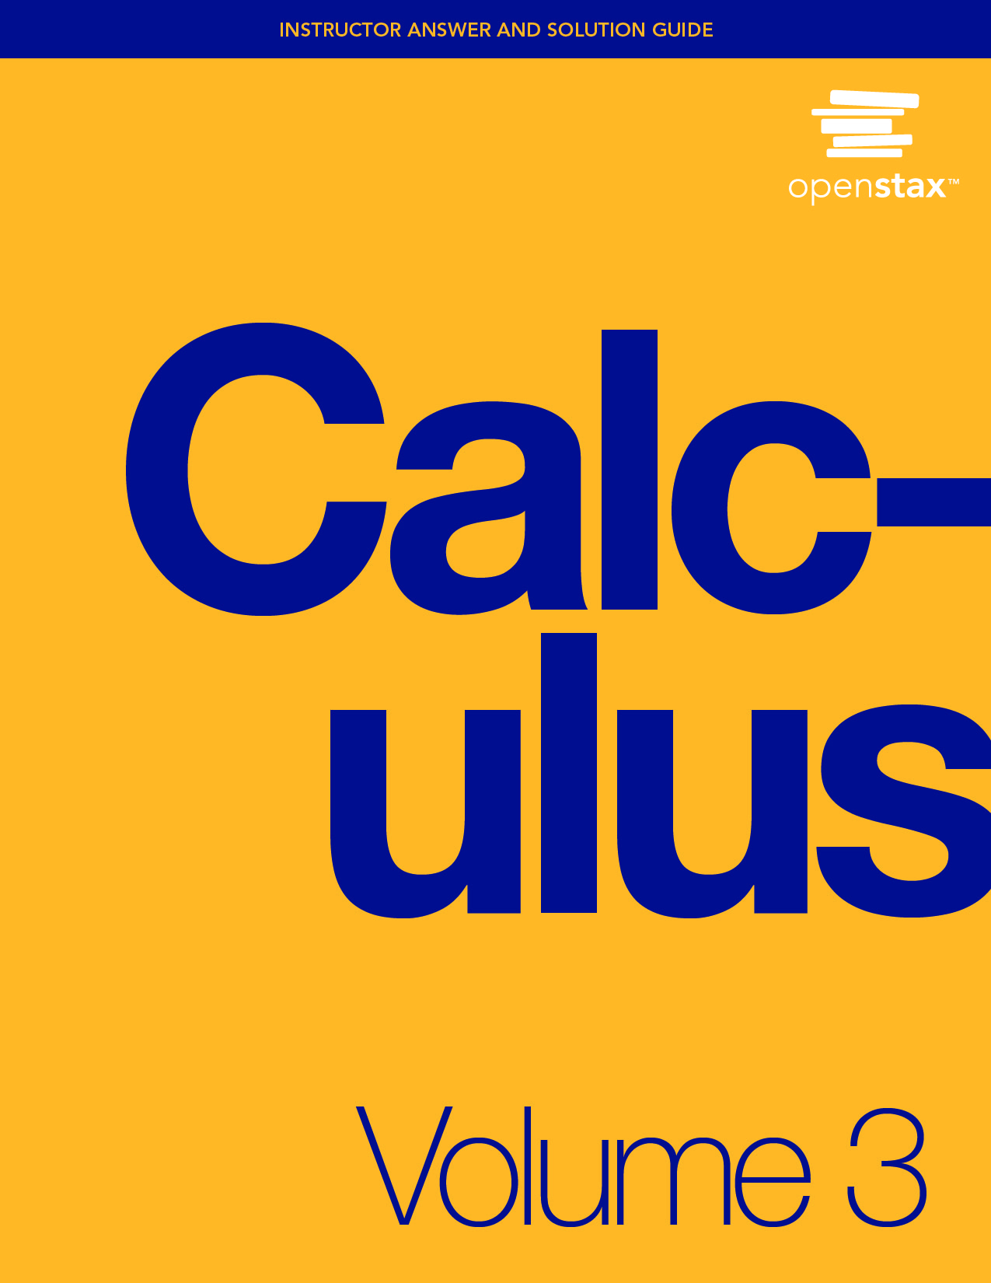

**Chapter 1**

**Parametric Equations and Polar Coordinates**

**1.1 Parametric Equations**

**Section Exercises**

**For the following exercises, sketch the curves below by eliminating the parameter *t*. Give the orientation of the curve.**

1.  

Answer:

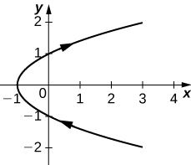

orientation: bottom to top

1. 

Answer:

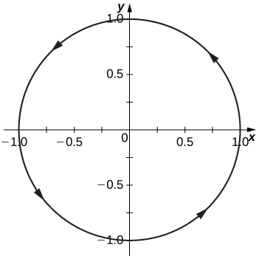

orientation: counterclockwise

1. 

Answer:

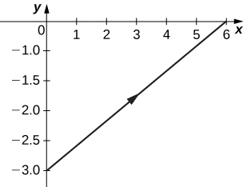

orientation: left to right

1. 

Answer:

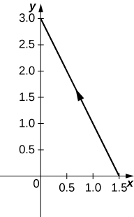

orientation: right to left

**For the following exercises, eliminate the parameter and sketch the graphs.**

1. 

Answer: 

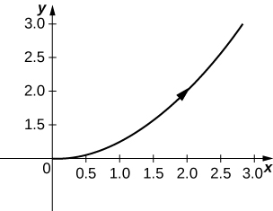

**For the following exercises, use technology (CAS or calculator) to sketch the parametric equations.**

1. **[T]** 

Answer:

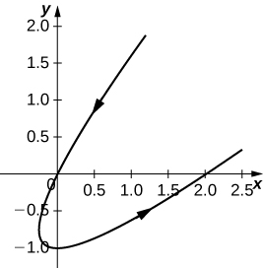

1. **[T]** 

Answer:

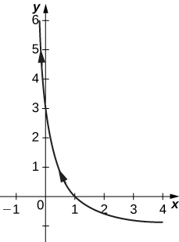

1. **[T]** 

Answer:

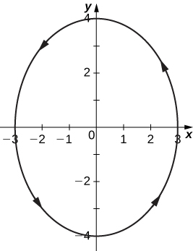

1. **[T]** 

Answer:

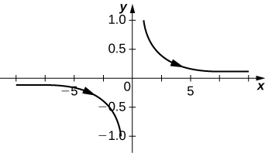

**For the following exercises, sketch the parametric equations by eliminating the parameter. Indicate any asymptotes of the graph.**

1. 

Answer:

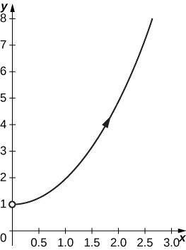

1. 

Answer:

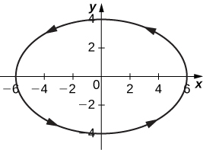

1. 

Answer:

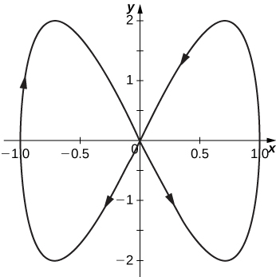

1. 

Answer:

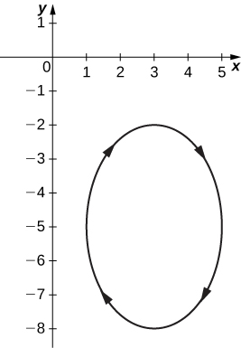

1. 

Answer:

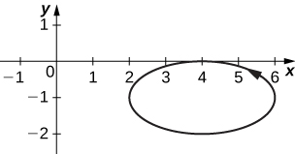

1. 

Answer:

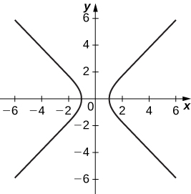

Asymptotes are  and 

1. 

Answer:

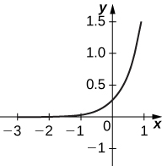

** is a horizontal asymptote.

1. 

Answer:

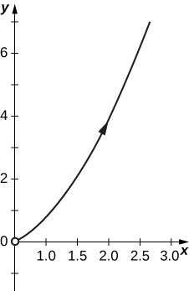

1. 

Answer:

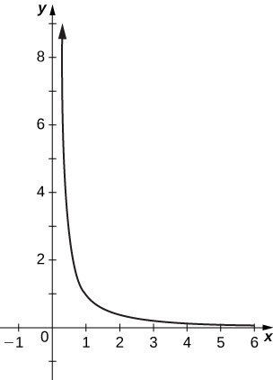

Horizontal asymptote:  Vertical asymptote: 

1. 

Answer:

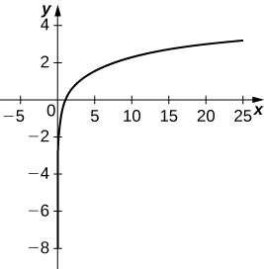

1. 

Answer:

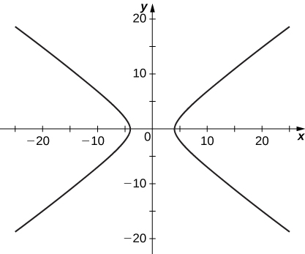

**For the following exercises, convert the parametric equations of a curve into rectangular form. No sketch is necessary. State the domain of the rectangular form.**

1. 

Answer:  domain: .

1. 

Answer:  domain: 

1. 

Answer:  domain 

1. 

Answer:  domain 

1. 

Answer:  domain: all real numbers.

1. 

Answer:  domain: 

1. 

Answer: ; domain: .

1. 

Answer:; domain: 

1. 

Answer:  domain: 

1. 

Answer: 

1. 

Answer:  domain: 

1. 

Answer:  domain: all real numbers.

1. 

Answer:  domain: 

1. 

Answer:  domain: 

1. where *n* is a natural number

Answer:  domain: 

1.  where 

Answer:  a linear function; domain: 

1. 

Answer:  domain: 

1. 

Answer:  domain: all real numbers.

**For the following exercises, the pairs of parametric equations represent lines, parabolas, circles, ellipses, or hyperbolas. Name the type of basic curve that each pair of equations represents.**

1. 

Answer: line

1. 

Answer: line

1. 

Answer: parabola

1. 

Answer: circle

1. 

Answer: circle

1. 

Answer: hyperbola

1. 

Answer: ellipse

1. 

Answer: ellipse

1. 

Answer: hyperbola

1. 

Answer: hyperbola

1. Show that  represents the equation of a circle.
2. Use the equations in the preceding problem to find a set of parametric equations for a circle whose radius is 5 and whose center is 

Answer: 

**For the following exercises, use a graphing utility to graph the curve represented by the parametric equations and identify the curve from its equation.**

1. **[T]** 

Answer: The equations represent a cycloid.

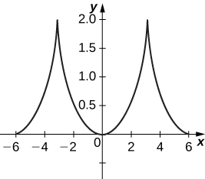

1. **[T]** 

Answer: The equations represent the mirror image of a cycloid, the graph of which is symmetric with the *y*-axis.

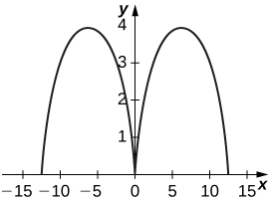

1. **[T]** 

Answer:

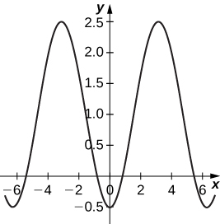

1. An airplane traveling horizontally at 100 m/s over flat ground at an elevation of 4000 meters must drop an emergency package on a target on the ground. The trajectory of the package is given by  where the origin is the point on the ground directly beneath the plane at the moment of release. How many horizontal meters before the target should the package be released in order to hit the target?

Answer: About 2857 meters.

1. The trajectory of a bullet is given by  where   and  When will the bullet hit the ground? How far from the gun will the bullet hit the ground?

Answer: 22,092 meters at approximately 51 seconds.

1. **[T]** Use technology to sketch the curve represented by 

Answer:

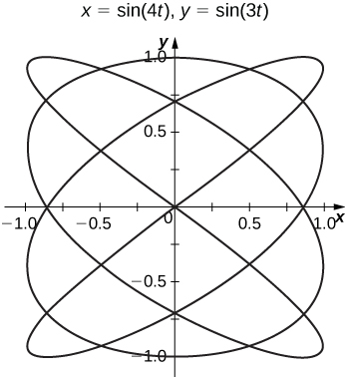

1. **[T]** Use technology to sketch 

Answer:

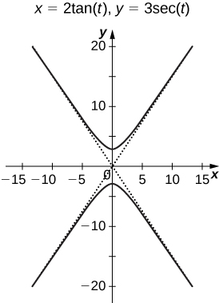

1. Sketch the curve known as an *epitrochoid*, which gives the path of a point on a circle of radius *b* as it rolls on the outside of a circle of radius *a*. The equations are

 Let 

Answer:

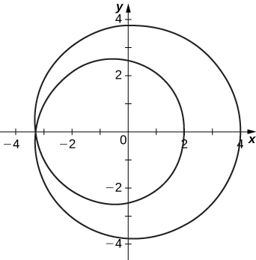

1. **[T]** Use technology to sketch the spiral curve given by  from 

Answer:

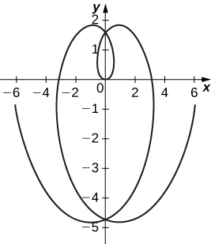

1. **[T]** Use technology to graph the curve given by the parametric equations  This curve is known as the witch of Agnesi*.*

Answer:

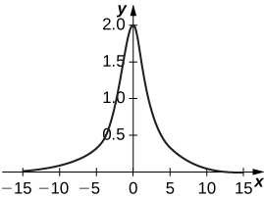

1. **[T]** Sketch the curve given by parametric equations  where 

Answer:

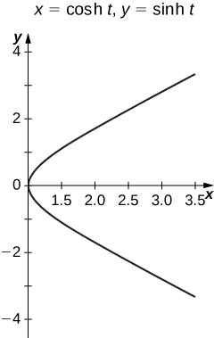

**Student Project**

**The Witch of Agnesi**

1. On the figure, label the following points, lengths, and angle:
2. *C*is the point on the *x*-axis with the same *x*-coordinate as *A*.
3. *x* is the *x*-coordinate of *P*,and *y* is the *y*-coordinate of *P*.
4. *E* is the point 
5. *F* is the point on the line segment *OA* such that the line segment *EF* is perpendicular to the line segment *OA*.
6. *b* is the distance from *O* to *F*.
7. *c* is the distance from *F* to A.
8. *d* is the distance from *O* to *B*.
9.  is the measure of angle 

Answer:

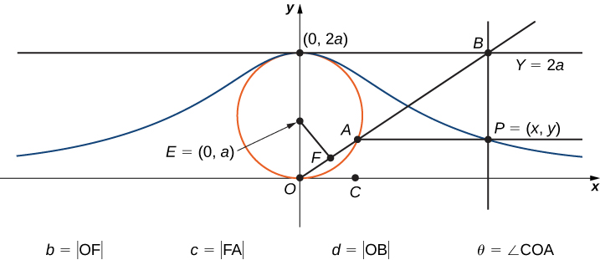

**The goal of this project is to parameterize the witch using  as a parameter. To do this, write equations for *x* and *y* in terms of only **

1. Show that .

Answer: The triangle formed by  is a right triangle. Therefore . Solving for  yields 

1. Note that  Show that  When you do this, you will have parameterized the *x*-coordinate of the curve with respect to  If you can get a similar equation for *y*, you will have parameterized the curve.

Answer: The equation  follows from the definition of cosine in the right triangle formed by By 2), we have that



1. In terms of  what is the angle 

Answer: 

1. Show that 

Answer: Note that the triangle with vertices is a triangle inscribed in a circle where one of the sides is a diameter of the circle. By Thales’ Theorem, this triangle is a right triangle with hypotenuse the side from . Using the answer from 4., the length of  is  But  is also . Therefore



1. Show that 

Answer: From the figure, it is clear that  is the vertical component of the side length . Using the answer from 5., we have that



1. Show that  You have now parameterized the *y*-coordinate of the curve with respect to 

Answer: Note that



Using the answer from 6., we have that 

1. Conclude that a parameterization of the given witch curve is



Answer: Using the answers from 3. And 7., we have the desired parameterization.

1. Use your parameterization to show that the given witch curve is the graph of the function 

Answer: If  then



**Student Project**

**Travels with My Ant: The Curtate and Prolate Cycloids**

1. What is the position of the center of the wheel after the tire has rotated through an angle of *t*?

Answer: 

1. Use geometry to find expressions for  and for 

Answer: 

1. On the basis of your answers to parts 1 and 2, what are the parametric equations representing the curtate cycloid?

Answer: 

1. Using the same approach you used in parts 1– 3, find the parametric equations for the path of motion of the ant.

Answer: 

1. What do you notice about your answer to part 3 and your answer to part 4?

Answer: They are the same.

This file is copyright 2016, Rice University. All Rights Reserved.